Bandit level 15 to level 16
To login to the level 15 use the username as
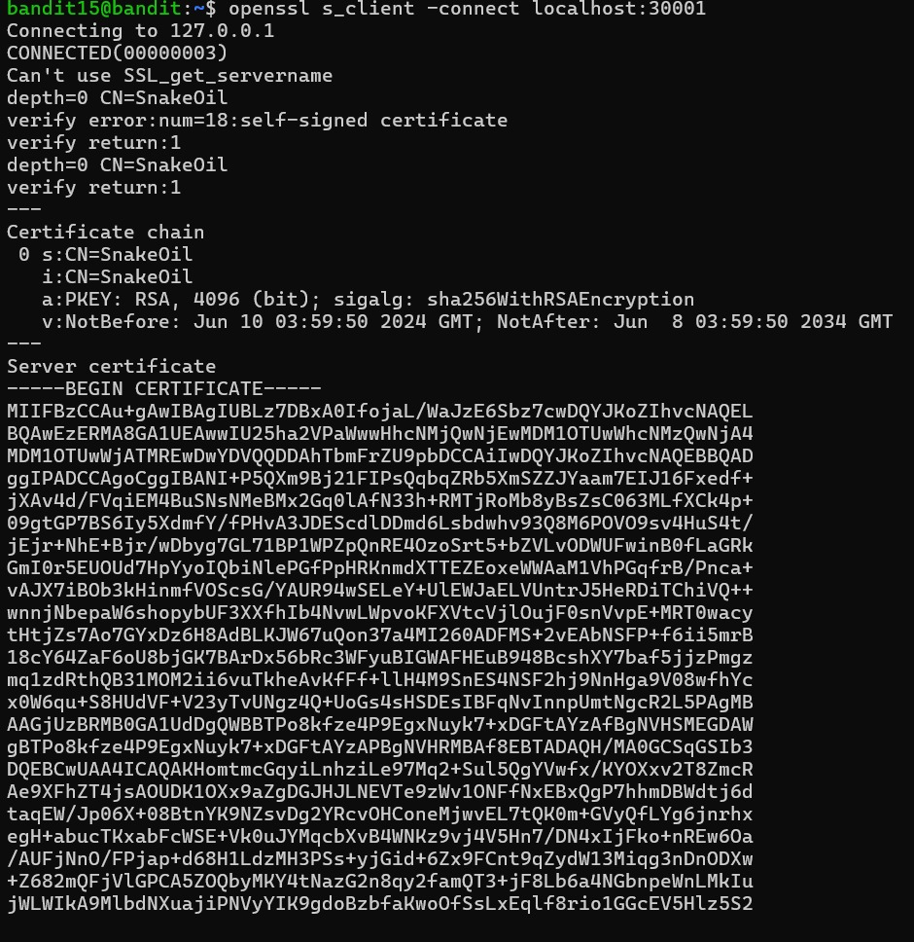
Finally you will get the password for level 16 also

